**SP/RM[1,1] – Using Software Key**

**Type in your score here 🡪 ____ out of 30 points possible**

1. (5 points) Ponder/Reflect Exercise – Reflect on what you have learned from this portion of the class. Examples of what you can do are: a brief outline of material covered, insights you gained from class or personal study, or items you feel that you need to follow up or work on. (3-5 sentences)

**Any thoughtful answer is sufficient.**

2. Consider the experiment described in Example 7.11 on page 261, with data given on the bottom of page 281.

(a) Using the file auxin.csv on the homework page, run the analysis to check your work from the decomposition homework. Discuss the results of the experiment, including the significance or non-significance of each hypothesis test of interest (i.e., discuss the test for each factor). For the auxin data, answer the following questions:

1. (5 points) Check the assumption of residuals being normally distributed using **software**.

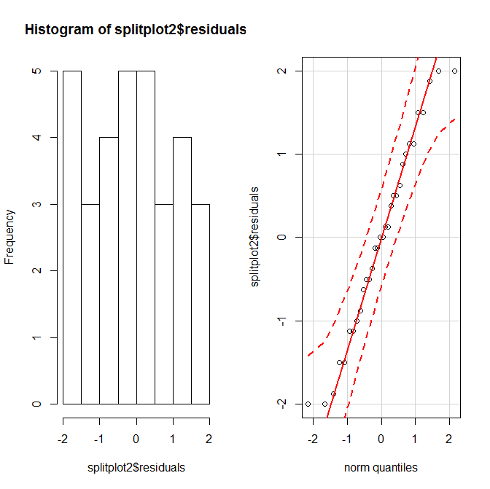

**It appears that the residuals are normal. We are probably OK going forward with this test.**

1. (4 points) Get an ANOVA table using **software**

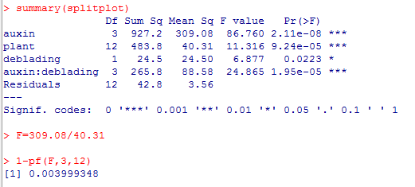

1. (8 points) For the effect of interest: i) state the null and alternative hypotheses, ii) give the test statistic, iii) give the degrees of freedom, iv) state the p-value, v) determine whether you should reject or not reject the null hypothesis, and vi) write a sentence which gives an appropriate conclusion.

**Auxin**

1. **Ho: µA1= µA2 = µA3  = µA4  Ha: at least one of the population means is**
2. **Test Statistic F=7.727**
3. **Degrees of Freedom Num df=3 Den df=12**
4. **P-value = 0.004**
5. **Since the p-value is less than 0.05, we would reject the null hypothesis**
6. **Therefore, we have sufficient evidence that at least one of the population means is different**

**Deblading**

1. **Ho: µDB1= µDB2  Ha: at least one of the population means is different (µDB1 ≠ µDB2 )**
2. **Test Statistic F= 6.877**
3. **Degrees of Freedom Num df=3 Den df=12**
4. **P-value = 0.022**
5. **Since the p-value is less than 0.05, we would reject the null hypothesis**
6. **Therefore, we have sufficient evidence that at least one of the population means is different**

**Interaction**

1. **Ho: There is no interaction between Deblading and Auxin Ha: There is an interaction**
2. **Test Statistic F = 24.865**
3. **Degrees of Freedom Num df=3 Den df=12**
4. **P-value = Close to Zero**
5. **Since the p-value is LESS than 0.05, we would reject the null hypothesis**
6. **Therefore, we have sufficient evidence that there is an interaction between Deblading and Auxin**
7. (1 point) What is the response variable? **The number of days after deblading before the leaf pair falls off.**
8. (1 point) What are the experimental factors and what are the levels for each?  
   **Level of Auxin – Control, Lanolin, Low Auxin, High Auxin**
9. (1 point) What blocking used in this study? If so, what are the blocks? **Yes, the** **16 Coleus plants**
10. What is the statistical model for the observed values, defining all symbols used? (2 points)

$y_{ijk}=μ+α_{i}+β_{j(i)}+γ_{k}+{\left(αγ\right)}_{ik}+ε_{ijk} i=1,2,3,4; j=1,2,…,16; k=1,2$

$α_{i}=effect of the i^{th}level of auxin$

$β_{j(i)}=effect of j^{th}level of tree nested in i^{th}level of auxin$

$γ_{k}=effect of the j^{th}level of deblading (yes or no)$

${\left(αγ\right)}_{ik}=effect of the (i{j)}^{th}level of the interaction (auxin*deblading)$

$ε_{ijk}=residual error for the observed value y_{ijk}$

1. What are the null and alternative hypotheses using the model in problem vii? (3 points)

**For the auxin: $H_{o}:α_{1}=α_{2}=α_{3}=0 H_{a}:at least one of the α^{'}s is not equal to zero$**

**For the deblading: $H_{o}:γ_{1}=γ_{2}=0$ $H_{a}:at least one of the γ^{'}s is not equal to zero$**

**For the interaction: $H_{o}:No interaction with auxin and deblading$**

$H_{a}:There is interaction with auxin and deblading$

**It appears that we would reject all of the null hypotheses and say that the auxin and deblading effects are significant as well as the interaction between the two factors are significant.**